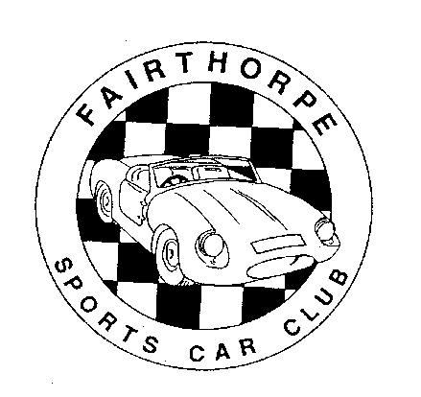
THE FAIRTHORPE SPORTS CAR CLUB
FAIRTHORPE TURNER ROCHDALE TORNADO
ASHLEY FALCON EB & HISTORIC SPECIALS

MEMBERSHIP APPLICATION/RENEWAL FORM

Please complete this form and return it with your remittance to: Anna Bentley, Membership Secretary
2 Fawn Rise, Henfield, West Sussex, BN5 9EZ

I/We* wish to APPLY FOR/RENEW* Membership of the above Club for the
12 months/5 years* to 30th April (Please enter year & *delete as necessary)

Name (s) *Mr/Mrs ………………………………………………
*Mr/Ms ………………………………………………
Address ……………………………………………………………………………………..
……………………………………………………………………………………..
……………………………………………..Post Code………………………….
Tel. No …..………………………………….. email …………….……………………………....

DETAILS OF CAR(S)

Make …………………………………………Model…………………..…………………………
Registration No …………………………..…Year of Registration…………………..…………
Chassis No ………………………………….
Engine Type …...…………..………………..Capacity…………...……………………………..
Other Information …………………………………………………………………………………

Do you want your Newsletter by email only? YES NO

MEMBERSHIP FEES One Year 5 years Please enter amount
UK £24 £120 _____________
O'seas Newsletter by email £24 £120 _____________
Europe Newsletter by post £27 £135 _____________
Rest of World N/L by post £30 £150 _____________
For Family membership add £ 1 £ 5 _____________
TOTAL ENCLOSED _____________

Overseas Payment by PayPal – Contact; brian.fscc@btinternet.com
If you wish to pay by another method contact Brian Shaw (as above)
UK payments accepted by Cheque (payable to FAIRTHORPE SPORTS CAR CLUB)
Or PayPal (to brian.fscc@btinternet.com) Or for direct bank transfer contact Brian Shaw.

However you pay please complete/sign & return this Form, it is used to keep the Membership Listing up to date.

Declaration:- In applying for Membership/Renewal of membership to the Fairthorpe Sports Car Club, I understand that my personal information will be held by the Fairthorpe Sports Car Club in accordance with the Club’s GDPR statement, available on request.
I also understand that my personal information will be deleted at my request.
I agree to my name, address, telephone number, email address and vehicle details being held by the Fairthorpe Sports Car Club.

Signature ………………………………………………………….. Date……………………….
03/22

REGALIA Cost plus Post & Packing Number Amount
UK Europe Rest
of World

Fairthorpe
by John Allan
Hardback book £23.99 £5.00 £8.50 £17.00 ______ ______

Turner Sports Cars
By Peter Tutthill
Hardback Book £18.50 £5.00 £9.65 £20.00 ______ ______
Softback Book £11.95 £3.70 £8.50 £17.00 ______ ______

FSCC Car Badge
Enamel Type £14.00 £1.50 £3.80 £5.00 ______ ______

Cloth Badge (Sew on type)
Fairthorpe £4.00 70p £1.85 £2.55 ______ ______

Turner £4.00 70p £1.85 £2.55 ______ ______

Tornado £3.00 70p £1.85 £2.55 ______ ______

Ashley £4.00 70p £1.85 £2.55 ______ ______

Key Fob £3.00 £1 £3.25 £4.20 ______ ______

Window Sticker £1.00 70p £1.70 £1.70 ______ ______

Newsletter Binder £6.50 £3.10 £5.10 £8.75 ______ ______

Beanie Hats (Blue with Club badge in full colour)
£9.00 £1.00 £3.00 £3.70 ______ ______

Polo Shirts - Embroidered Club Badge in full colour
Grey
Burgundy
Blue £18.00 £3.10 £7.25 £14.50 ______ ______
Limited quantity, colour & sizes available, please enquire before ordering.

Polo Shirts - Embroidered with either Fairthorpe, or Turner or Tornado Badge to special order.
Many shirt colours available. Please ask for details.

Mouse Mats
(various designs) £6 each
or 3 for £15 £3.00 £4.00 £6.00 ______ ______

TOTAL REGALIA £_________

For Payment see under Membership Fees.

03/22

